**EXP NO : 12 DATE :**

**IMPLEMENT CODE OPTIMIZATION TECHNIQUES COPY PROPAGATION**

**AIM:**

The aim is to implement code optimization techniques like Dead Code Elimination (DCE) and Common Subexpression Elimination (CSE) to improve the efficiency and performance of a program. These techniques are applied to intermediate code (e.g., Three-Address Code or TAC) during the compilation process.

**ALGORITHM:**

* The desired header files are declared.
* The two file pointers are initialized one for reading the C program from the file and one for writing the converted program with constant folding
* The file is read and checked if there are any digits or operands present.
* If there is, then the evaluations are to be computed in switch case and stored.
* Copy the stored data to another file.
* Print the copied data file.

**PROGRAM:**

#include <stdio.h> #include <stdlib.h> #include <string.h>

#define MAX 100 typedef struct {

char lhs[10];

char op1[10]; char op[5]; char op2[10];

} Instruction;

int is_copy_instruction(Instruction *ins) {

return strcmp(ins->op, "=") == 0 && strlen(ins->op2) == 0;

}

void copy_propagation(Instruction ins[], int count) { for (int i = 0; i < count; i++) {

if (is_copy_instruction(&ins[i])) { char from[10], to[10]; strcpy(to, ins[i].lhs); strcpy(from, ins[i].op1);

for (int j = i + 1; j < count; j++) { if (strcmp(ins[j].op1, to) == 0)

strcpy(ins[j].op1, from);

if (strcmp(ins[j].op2, to) == 0) strcpy(ins[j].op2, from);

}

}

}

}

int main() {

FILE *fin = fopen("input.txt", "r");

if (!fin) {

printf("Error opening input.txt\n"); return 1;

}

Instruction ins[MAX]; int count = 0;

char line[100];

while (fgets(line, sizeof(line), fin)) {

// Skip blank lines

if (strlen(line) <= 1) continue;

Instruction temp; temp.op[0] = '\0';

temp.op2[0] = '\0';

int tokens = sscanf(line, "%s = %s %s %s", temp.lhs, temp.op1, temp.op, temp.op2); if (tokens == 2) {

// It's a copy statement like: a = b

strcpy(temp.op, "=");

temp.op2[0] = '\0';

} else if (tokens != 4) { printf("Invalid line: %s\n", line); continue;

}

ins[count++] = temp;

}

fclose(fin);

// Perform copy propagation copy_propagation(ins, count);

// Print optimized code

printf("\nOptimized Code (Copy Propagation Only):\n\n"); for (int i = 0; i < count; i++) {

if (strcmp(ins[i].op, "=") == 0 && strlen(ins[i].op2) == 0) printf("%s = %s\n", ins[i].lhs, ins[i].op1);

else

printf("%s = %s %s %s\n", ins[i].lhs, ins[i].op1, ins[i].op, ins[i].op2);

}

return 0;

}

**OUTPUT :**

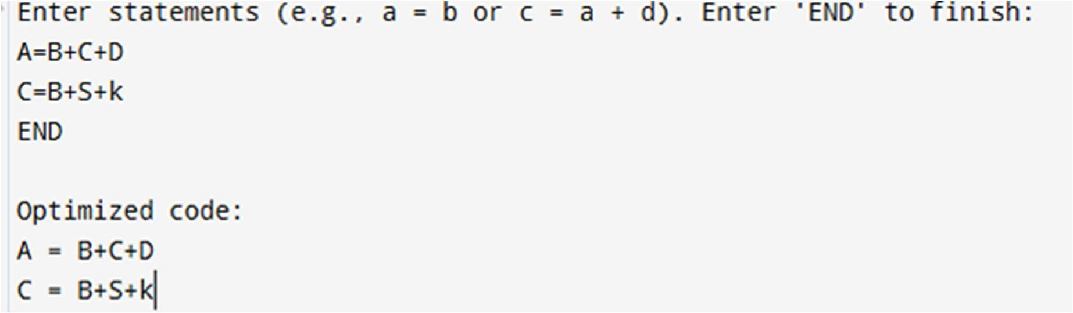

|  |  |
| --- | --- |
| **Implementation** |  |
| **Output/Signature** |  |

**RESULT:**

Thus the above to implement code optimization techniques for copy propagation is executed successfully.